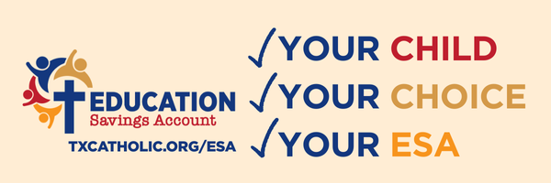

**Parents Know Best**

The new Texas Education Savings Account (ESA) program is a major step forward for families who want the best for their children. Parents are empowered to ensure school funding will follow your child.

At [INSERT SCHOOL NAME], we believe in [INSERT SCHOOL MISSION]. The ESA program allows more families to participate in our mission of forming students for academic success and a life rooted in faith.

**Your Child. Your Choice. Your ESA.**

Beginning in 2026, Texas ESAs will be available to all families, with priority for students with disabilities and low-income households. Most qualifying students will receive about $10,000 each year to use for tuition, textbooks, tutors, uniforms, and other approved educational expenses. Children with disabilities may receive up to $30,000 in funding.

Learn more by visiting us to see if a Texas ESA can help your family in the 2026-2027 school year.

**Make Catholic education possible for your family today.**  
**LEARN MORE AT TXCATHOLIC.ORG/ESA**